Assignment 1- Crash and then Burn
Due Week 3

Task 1 - Crash, And Then Burn
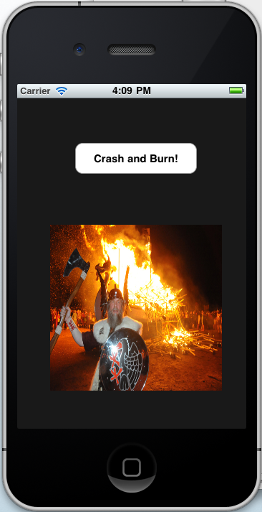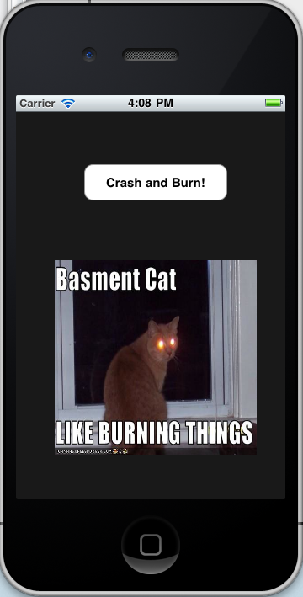

Task 2 - Debug Essay
This is very difficult debug assignment. There is error message is called EXC_BAD_ACCESS. I google it, found this error is due to three main mistakes.

- An object is not initialized
- An object is already released
- Something else that is not very likely to happen
I checked each variable. I add alloc and init method. It still crash. Also there is no release method is called before access a variable.

I use the NSLog method to check most variables. The variable _nextIndex is always a large number. There is a if statement in the _nextImageFilename, the conditions is always skipped, due to high number. Then I try to initiate it. Like
_nextIndex = 0;
the above code will not crash. But it only show one image, when I click the Crash and burn button. I use NSLog to view the value before and after _nextIndex++; I found the number is always 0 then 1. The problem is when button is clicked, the method carshAndBurnBtnPressed and _nextImageFilename will reset the _nextImage’s value. To protect this value reset again, I add if statement to control the values changes.

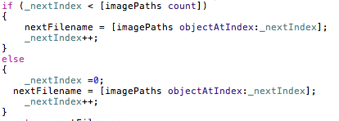

When the project is running first time, (_nextIndext is uninitialized) it will skip conditions, value is set to 0. Next time the _nextIndex is less than imagePaths count. It will obtain the array’s object at the index. If the last image shows. The _nextIndext value will greater than imagePaths count, then Its value will set to 0.

Task 3 - XIB Files
XIB is the extension name of NIB file. It is called Nextstep Interface Builder. It is used to control the interface controller. The NIB file can be present the view of application. It is drawn, not programmatically. The developer can know the result instantly. The interface describes the all elements in the application, likes view, windows, button, menu, sound and some non-visual elements. It can respond users’ action, like drag, click, or double click.

In the interface builder, developers can make the connection with File’s Owner Object, which is the most important object in Nib file. The reason of important of this object is that it can connect the code and contents of the NIB file. If users click a button, a method may be triggered. It can decide elements loadings. The First Responder is using to interactive the user’s action.

The Top-level object is created when NIB file is loading. Developer should always use pointer links this objects.

The NIB file can also represent the image and sound resource. When nib file is loading, it will catch the image and sound for quick responds.

According to the nib file design guide. It’s better to build a single file. The menu or some components are useless could build a separate files.

The nib file is controlled by NSBundle class. This class can used to load the image, sound file etc.

